**Week 6 Solutions**

**React**

1. **ReactJS-HOL** .

Create a new react application using *create-react-app* tool with the name as “blogapp”

The code and the folder structure is attached in the **Week 6/4 reactjs HOL/** **blogapp** folder

**Output :-**

**Chrome – http://localhost:3000/**

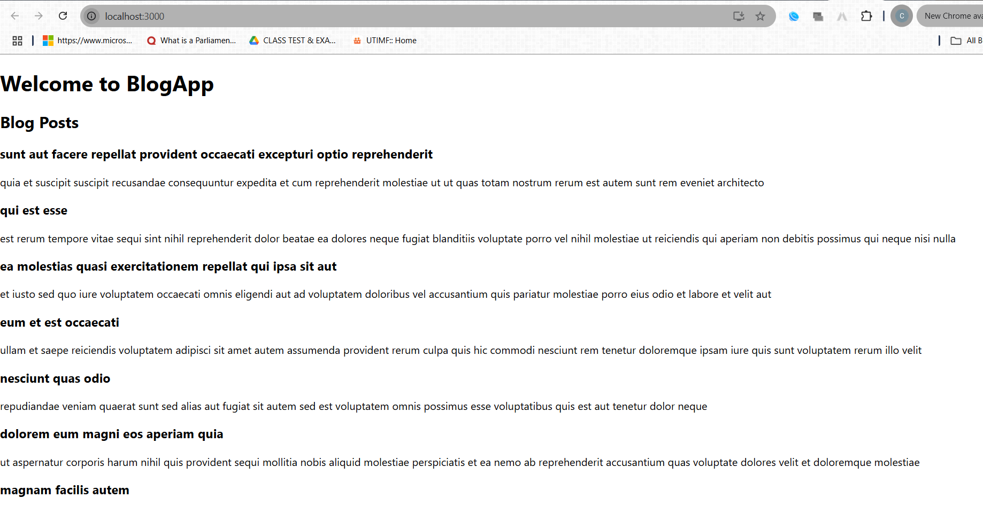

**The hands on file and folder is attached along with it**